# CS 255 Business Requirements Document Template

Complete this template by replacing the bracketed text with the relevant information.

This template lays out all the different sections that you need to complete for Project One. Each section has guiding questions to prompt your thinking. These questions are meant to guide your initial responses to each area. You are encouraged to go beyond these questions using what you have learned in your readings. You will need to continually reference the interview transcript as you work to make sure that you are addressing your client’s needs. There is no required length for the final document. Instead, the goal is to complete each section based on your client’s needs.

**Tip:** You should respond in a bulleted list for each section. This will make your thoughts easier to reference when you move into the design phase for Project Two. One starter bullet has been provided for you in each section, but you will need to add more.

## System Components and Design

### Purpose

*What is the purpose of this project? Who is the client and what do they want their system to be able to do?*

* The client, DriverPass, is a company that was created to provide driver education software. They would like a system that offers practice driving tests, online classes, and the ability to request on-the-road training, because they believe a similar system does not exist.
* The purpose of this project is to demonstrate a realistic scenario on how system design happens.

### System Background

*What does DriverPass want the system to do? What is the problem they want to fix? What are the different components needed for this system?*

* DriverPass is looking for a system that has a digital presence, as well as a physical component. The vision is to have a system that is entirely online, and specifically requested to be cloud based, where one can take online practice tests, online classes, and when they are ready, take a physical driving test with a DriverPass instructor.
* In the owner Liams mind, there is no available solution to having an online driving test platform that allows one to schedule a real driving test with their instructor.
* There are multiple, interlinked components in the proposed system. There is the UI/structure of the system, which must be present in all pages and parts of the digital portion. There is a test component, which includes all relevant online test pieces such as displaying test progress, choosing a new test, etc. There is the information component, which displays relevant information of the user/student. Then there is the driver notes component, which provides detailed information about physical driving times and scheduling tests. Finally, there is the back-office component of having a functional “admin” style page for a DriverPass employee to add or change student information. An unrelated component would be the actual scheduling of the DriverPass instructors and pairing them with students, however this is unrelated to the digital portion of the system.

### Objectives and Goals

*What should this system be able to do when it is completed? What measurable tasks need to be included in the system design to achieve this?*

* This system has multiple requirements upon completion.
* 1. A student must be able to view available online tests. They must be able to take multiple practice tests as well as view prior scores and progress. This was not explained very clearly, and the client should provide more information.
* 2. A student must be able to have their initial account setup done by DriverPass, and after the initial setup must be able to modify their own personal information. This information must be viewable by both the student and DriverPass.
* 3. A student must be able to view their past physical driving test results and be able to schedule another test. They must be able to have the option of selecting three different physical test packages. This component must be able to be easily added to in the future.
* 4. The account system should have a similar setup to all other online sites where a new password can be requested.
* 5. The system should be cloud based. The client does not want to have an on-site server or database.
* 6. Although not specified, the credit card information should be encrypted to prevent data leaks. It will not prevent a data leak itself but will help prevent credit card numbers from being stolen.
* 7. The UI must be consistent and easy to use when completed. The client wants a ready-to-use program and will possibly want updates in the future.
* 8. The client wants an update whenever the DMV changes their policies. This could be difficult. Does the client want a notification whenever their website (DMV) is changed or something else?
* 9. There must be some sort of back-office system where DriverPass can view reports of changes, student info, contact a student, etc.
* 10. The code should be cleanly written with the assumption that additions will be made in the future.

## Requirements

### Nonfunctional Requirements

*In this section, you will detail the different nonfunctional requirements for the DriverPass system. You will need to think about the different things that the system needs to function properly.*

#### Performance Requirements

*What environments (web-based, application, etc.) does this system need to run in? How fast should the system run? How often should the system be updated?*

* The proposed system will be required to run through an internet browser. Clients will be using the software from their home computer or cell phone so will need internet access to use it. The system should be of average speed and does not require a fast connection or response like a payment processing system might, but it also shouldn't be slow where clients get annoyed.

#### Platform Constraints

*What platforms (Windows, Unix, etc.) should the system run on? Does the back end require any tools, such as a database, to support this application?*

* The system should be able to run on any platform that has a modern internet browser, meaning Windows, MacOS, Linux, Android, etc. There is no need for a separate system for each platform since it will be browser based.

#### Accuracy and Precision

*How will you distinguish between different users?* *Is the input case-sensitive? When should the system inform the admin of a problem?*

* This is not explicitly described in the interview, however in similar online systems, different users will have different usernames acting as their login credentials or sometimes an email will be used. The input should not be case sensitive. I would think the system should inform the admin of a problem if the user is attempting to log into an admin account, otherwise I do not think it is necessary for the admin to be notified of anything during the login process.

#### Adaptability

*Can you make changes to the user (add/remove/modify) without changing code? How will the system adapt to platform updates? What type of access does the IT admin need?*

* The admin will have the ability to make changes to users without modifying code. This needs to be simple enough for the DriverPass secretary to be able to answer their phone and create a new user with all relevant details. The system should not be greatly affected by platform updates since it is browser based, however care should be taken when designing the system so it is not entirely dependent on something that may be changed in the future, such as when Java functionality was removed from web browsers a few years ago. The IT admin should have access to view system reports such as an IP access list, modifying basic system modules, disabling packages, and viewing error reports.

#### Security

*What is required for the user to log in? How can you secure the connection or the data exchange between the client and the server? What should happen to the account if there is a “brute force” hacking attempt? What happens if the user forgets their password?*

* A user is required to enter their username and password when logging in. Passwords should be encrypted using a modern, secure method to help prevent passwords from being seen by hackers. The account should be locked after a certain number of unsuccessful login attempts and the user should have to contact DriverPass to have them unlock their account if their security questions are answered correctly. A somewhat modern way of boosting account security is using 2FA (Two Factor Authentication) which relies on the user having their cell phone to validate a login, such as getting a text to verify it is really them.

### Functional Requirements

*Using the information from the scenario, think about the different functions the system needs to provide. Each of your bullets should start with “The system shall . . .” For example, one functional requirement might be, “The system shall validate user credentials when logging in.”*

* The system shall let a user login if credentials are validated.
* The system shall send a forgot password link if forgot password is clicked.
* The system shall display a home page when a user logs in.
* The system shall display test progress on the home page.
* The system shall be able to schedule a driving test online.
* The system shall let the user choose between different driving packages when scheduling.
* The system shall allow the IT admin to disable a package.
* The system shall allow an administrator to create and modify users.
* The system shall record new appointments and reservations as well as any changes made ti a file that can be downloaded.

### User Interface

*What are the needs of the interface? Who are the different users for this interface? What will each user need to be able to do through the interface? How will the user interact with the interface (mobile, browser, etc.)?*

* The interface should closely match the rough drawing provided by Liam. The main users for this interface will be the user/student, the administrator, the IT admin, the secretary/back office user, and the no account user (which may not be considered a user at all, but is important to consider). The average user account will be able to log in and will go to their own home page which will display driver info, test progress, etc. The administrator account will be able to see all user accounts, be able to modify them, and have the ability to look at reports. The IT admin will have a screen that lets them enable and disable packages, reset passwords, and perform general system maintenance. The secretary/back office user will be like the administrator account but limited to just creating and modifying accounts. The no user/guest user, which isn't a real user, is for those who do not have an account yet and will need to see a screen that persuades them to create an account. The user will be able to interact with the interface on a computer by clicking on different buttons and links to do things, and on a cell phone or other mobile device will need to tap. The interface should resize and restructure itself when it detects it is on a mobile device to enhance usability.

### Assumptions

*What things were not specifically addressed in your design above? What assumptions are you making in your design about the users or the technology they have?*

* It is assumed this system will not let users create an account without being manually approved.
* It is assumed there will need to be an off-site server.
* It is assumed there will be some sort of off-site security consultant of some sort maintaining the security of the back-end software.

### Limitations

*Any system you build will naturally have limitations. What limitations do you see in your system design? What limitations do you have as far as resources, time, budget, or technology?*

* DriverPass, although not explicitly mentioned, will have some sort of budget and development should be constrained to fit below that budget unless discussed.
* The client wants there to be an automatic notification of any changes the DMV makes in their state. This is most likely very difficult to do the way they want.
* The system has to work on whatever off-site hosting server is chosen.
* The system is limited by human actions, meaning it is necessary for DriverPass employees to keep the system running smoothly. This is not an automated system.

### Gantt Chart

*Please include a screenshot of the GANTT chart that you created with Lucidchart. Be sure to check that it meets the plan described by the characters in the interview.*

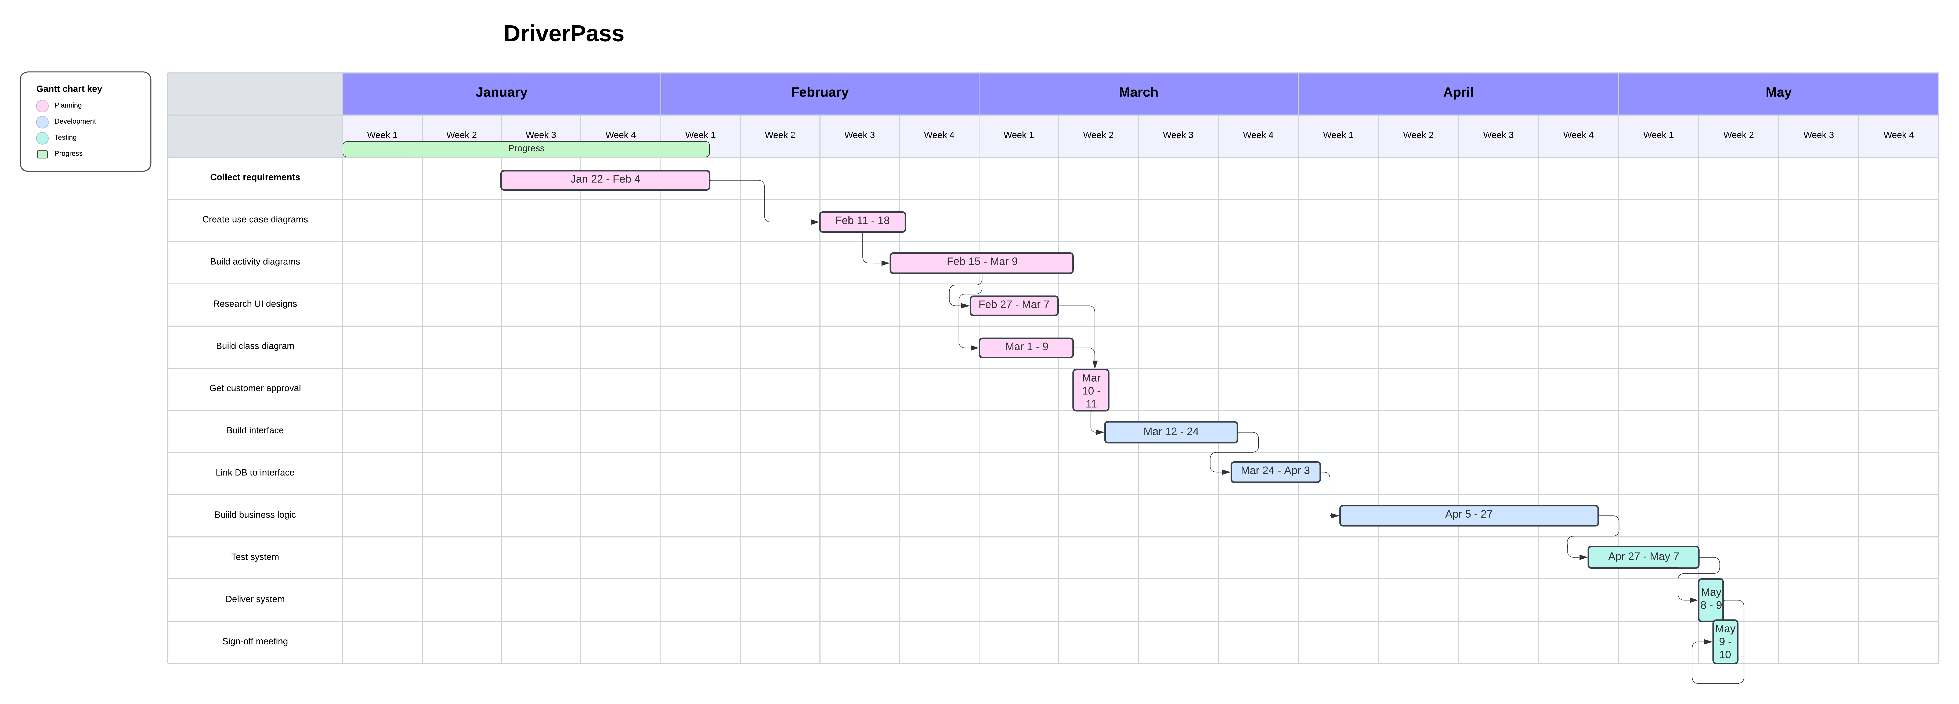This chart is done a little differently than I would have liked. The interview document provided did not clearly say who did what task. I would have liked to have had names assigned to each colored bar, but because it was not clear I relabeled it to be split by process.